***Purpose:*** One of the many great things we can use GRASS GIS for is to digitize, collapse, and extract longitudinal profiles from a stream. We can use these same tools to create a valley centerline or extract valley cross sectional profiles. This handout will walk through the tools and methods to extract longitudinal profiles, calculate stream length and valley centerline length, and create cross-sectional profiles of the stream valley. These outputs will be used, directly, as inputs into the Rosgen Classification table for slope and sinuosity. To learn more about these concepts, please refer to the recorded YouTube videos

Sinuosity: <https://youtu.be/rVs4MSw1e5s>

Slope/Longitudinal Profile: <https://youtu.be/SK2BFg2PmlQ>

In previous walkthroughs, we have gone over how to build locations and mapsets in GRASS GIS and how to load those into a map viewer. Please refer to those if you need a refresher. We will start with the John Day digital elevation model (DEM) and hillshade loaded into the viewer. Set the John Day DEM opacity to 65%. Load the CHaMP_Data and navigate to the location you are examining. We will be using a site on the Middle Fork of the John Day River (FID: 109) for our example. We first need to set up the vector digitization window (Figure 1).

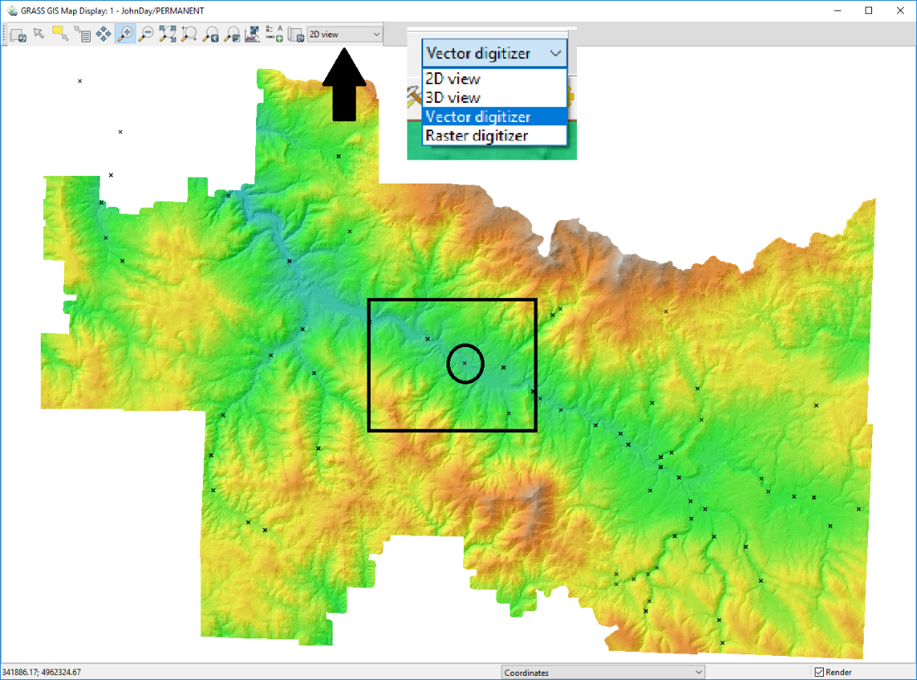

Figure 1. Extent of the John Day raster dataset with CHaMP data points. The black rectangle is outlining the computational extent, while the circle shows the workflow example data point. The black arrow is indicating the location of the digitizer option (shown in the callout box).

A new toolbar will appear in the Map Display window with options for vector creation and editing. Select “New vector map” (Figure 2) and a new window will open (Figure 3a). Once you have created the vector a second window will open (Figure 3b), where you can manage the attribute table for the vector. We’ll use the following workflow for digitizing both the stream banks and the valley outline. Digitizing practices typically suggest digitizing the same features multiple times, to ensure consistency (Micheli et al., 2004). Sometimes, when constrained by resolution or with features that are tough to define, this practice can help delineate a range of possible extents and distinguish areas with greater uncertainty. We will observe the following standards:

* All digitized features will be digitized three times.
* All features will be digitized at a scale of 1:2000.
* Name features clearly and iteratively, for clarity (Banks1/2/3, Valley1/2/3).
* Alternate between creating features (Banks1, Valley1, Banks2, Valley2, Banks3, Valley3) to reduce likelihood that “muscle memory” will skew outputs.

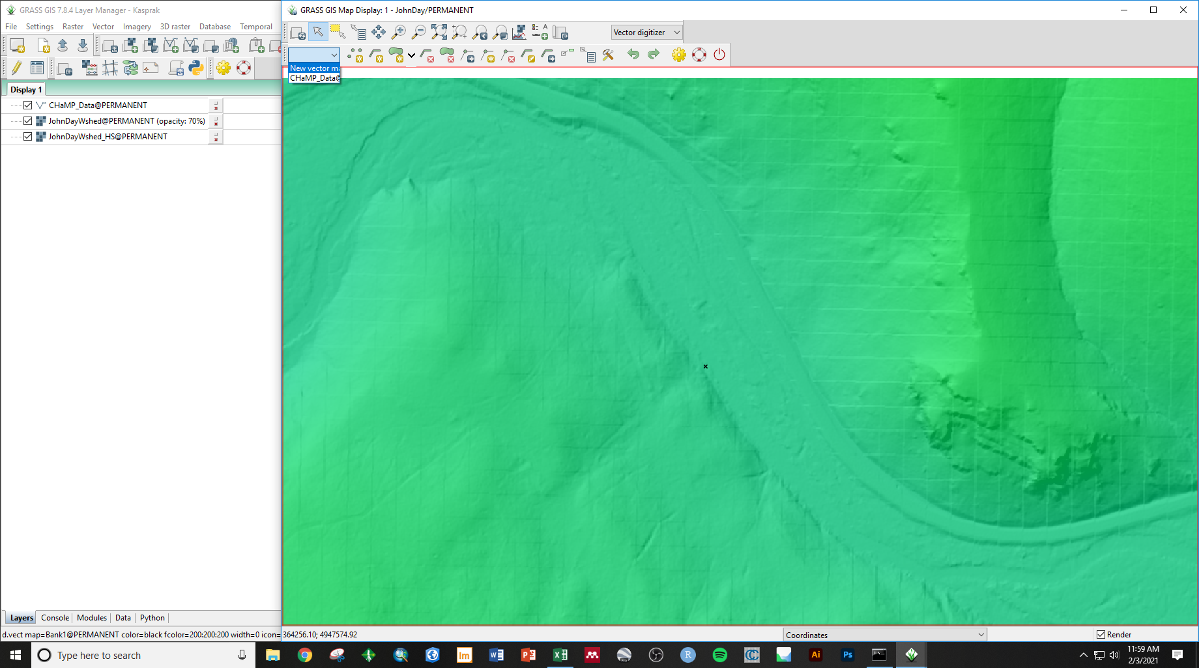

Figure 2. Vector digitizer toolbar and the dropdown menu for selecting which vector to edit/create a new vector.



Figure 3. New vector map windows. A) Window that opens when the New Vector Map option is selected. B) Window that opens after the vector has been created in A. We will be adding a “Length” column as well, which can be done in this menu. Under the “Add column” box, type in “Length” and change the Type to “Double” (double precision).

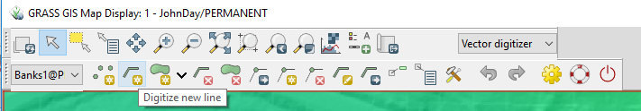

Figure 4. Location of the “Digitize new line” tool. Make sure that the feature you want to be adding a line to is selected in the left dropdown menu.

After creating the vector, select the “Digitize new line” tool (Figure 4). There are many different methods for digitizing streambanks, that depend on the available dataset. To maintain consistency, we will utilize the John Day DEM rather than a satellite image. The cells of this raster dataset have a spatial resolution of 1-meter. This is an elevation-based dataset, so we do not have to really worry about vegetation obstructing our vision. However, resolution and color ramps can impact how we interpret the elevation models. If we were digitizing a satellite image or an orthomosaic, we may be able to see the streambanks, but they could be covered by vegetation or flooded water. We will not have to deal with it in this dataset, but there are some examples of the different ways to digitize orthomosaic imagery in the Appendix.

For the channel banks, we will want look for distinct breaks in slope around the channel or obvious slopes in the hillshade. We’ll want to be careful! The road on the north side of the valley looks really similar to a river, but we can see that it is raised above the valley floor. It can be a bit tough to make out the edges of the river, but with careful digitizing at a consistent scale, we can get a good idea of the outline of the channel (Figure 5B). Rosgen (1994) suggests encompassing a distance of 20 channel widths (10 upstream, 10 downstream). In the example, the stream width was about 15 m wide, near the collection point. I digitized about 250 m upstream and downstream, with the sampling location datapoint in the center (Figure 5B), so I extended it a bit more than necessary, but within reason.

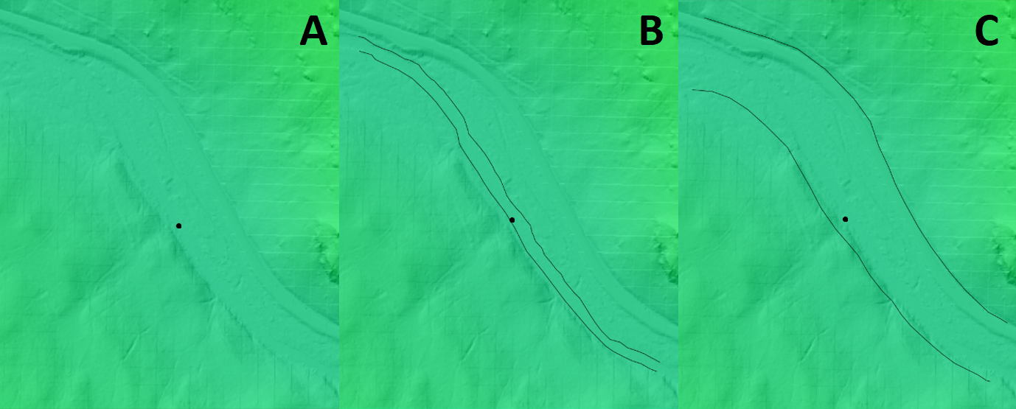

Figure 5. A) DEM of the Middle Fork of the John Day River with the example datapoint in the center of the map. B) An example of the digitized streambank lines from our first digitized banks. C) An example of the digitized valley extent from our first dataset.

The methods for digitizing the valley will be similar. We want to capture the extent of the stream valley and cover the same distance as we did with the banklines (Figure 5C). We can see some obvious breaks in slope, evident by the underlying hillshade. Sometimes, it is a bit tougher to tell, but we mostly want to get the general shape of the valley floor so that our valley centerline is accurately represented. We’ll repeat this process three times, for both the streambanks and the valley boundaries. Once we’ve finished that, we can move on to creating our centerlines.

Now that we have our digitized banklines and valley boundaries, the next task is to generate a centerline. To do this, we’ll first need to go to the *Settings* 🡪 *Addons extensions* 🡪 *Install extensions from addons* **(g.extension)** in the Layer Manager window. That will open a menu in which you can install and manage extensions within GRASS. Enter “**v.centerline**” in the search bar and double-click on it to install the extension. You can find the extension in the Modules tab in the Layer Manager window, under the Addons (expand the plus sign) (Figure 6). Once opened, all that needs to be input is the chosen vector map (Banks1/2/3 or Valley1/2/3) and the desired name for the output vector map. Maintaining a consistent naming convention is a good way to keep track of progress. For example, adding an “_centerline” to the end of your original names (i.e. Banks1_centerline), ensures that you know what step in the process you are at. Running this tool will give you a single line vector output that represents the calculated midpoint line between the two digitized lines you created to represent the banks or the valley (Figure 7.)

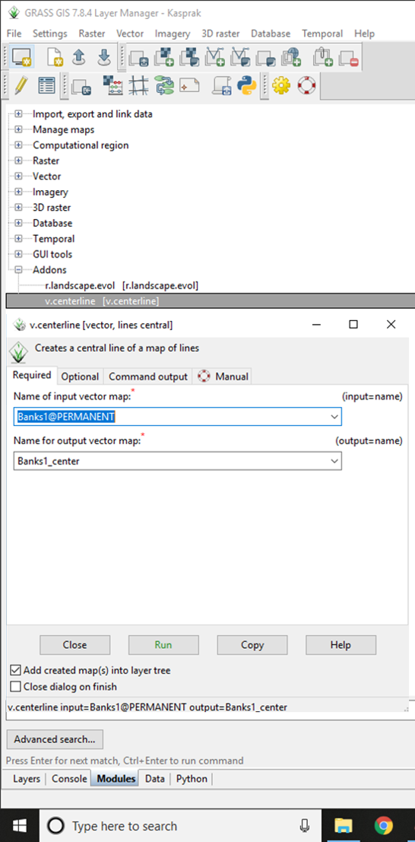

Figure 6. The Modules tab of the Layer Manager window with the “v.centerline” tool highlighted and the tool menu opened. The menu is where the input vector map (either the Banks1/2/3 or Valley1/2/3) will be selected and the output name will be input.

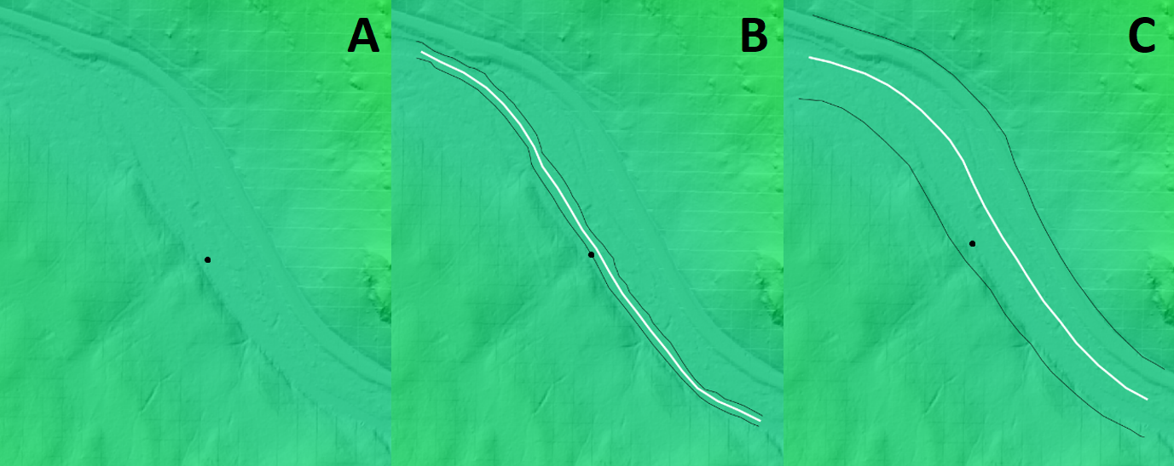

Figure 7. A) DEM of the Middle Fork of the John Day River with the example datapoint in the center of the map. B) An example of the digitized streambank lines (in black) and the related centerline (in white). C) An example of the digitized valley extent (in black) and the related centerline (in white).

While the v.centerline tool is relatively straightforward tool, the outcome of that tool does not contain everything we need to calculate sinuosity. We learned that, for sinuosity, we need to know the length of the river against the length of the valley. If you just use the “**v.to.db**” tool, which allows you to update vector geometry values for vector maps, nothing will populate in the attribute table for the centerline vectors. There is currently no attribute table for these vectors. To fix this, we first need to use the “**v.db.addtable**” tool. You can find the tool by either typing it into the Modules tab search bar, or under on the Modules window under *Database* 🡪 *Vector database connections* 🡪 *New table [v.db.addtable]*. Choose the vector map that you want to add a table to (either the Banks or Valley vectors) and simply run the tool. Using the **v.db.addcolumn** tool, which can be found in the same location as v.db.addtable, we will add a column to the vector we are editing. As the name and column type enter: “***Length double***” to name the column “Length” and assign it a double precision data type.

Now that we’ve added an attribute table to the v.centerline vector map, we need to populate the attribute with the line vector we created. Start by switching the mode in the Map Display to the Vector Digitizer (see Figure 1 for reference) if it is not currently in that mode. Make sure correct vector map is selected in the left dropdown menu. Then, we’ll click on the Update categories tool (Figure 8) and click on the line vector on the map. A window will pop up (Figure 8) that allows you to add a category into your attribute table. While this may be confusing, what we are really doing here is assigning a value to the vector line that did not automatically exist. Now, if we move to the Layers tab of the Layer Manager, right click on the vector we have been editing, and select “Show attribute data,” we will see that there is a data entry there, where previously it did not exist. Now, we can use the “**v.to.db**” tool, which we can find by searching, or in the Modules tab 🡪 Vector 🡪 Update database values from vector [v.to.db] (Figure 9). Follow the set up shown in Figure 9, where the name of the vector map is the vector you are currently editing, the value to upload (length) is selected from a dropdown list of geometries, and the name of the attribute column to populate is the length column we just created. Move to the Optional tab and select meters as the desired unit. Now, when you open up the attribute tables, you will see the length column has a registered value. These are the values we will use to calculate our sinuosity!

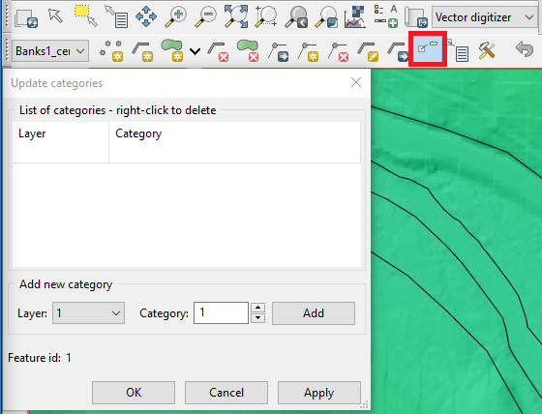

Figure 8. The location of the Update categories tool (red box), with the pop-up window highlighted.

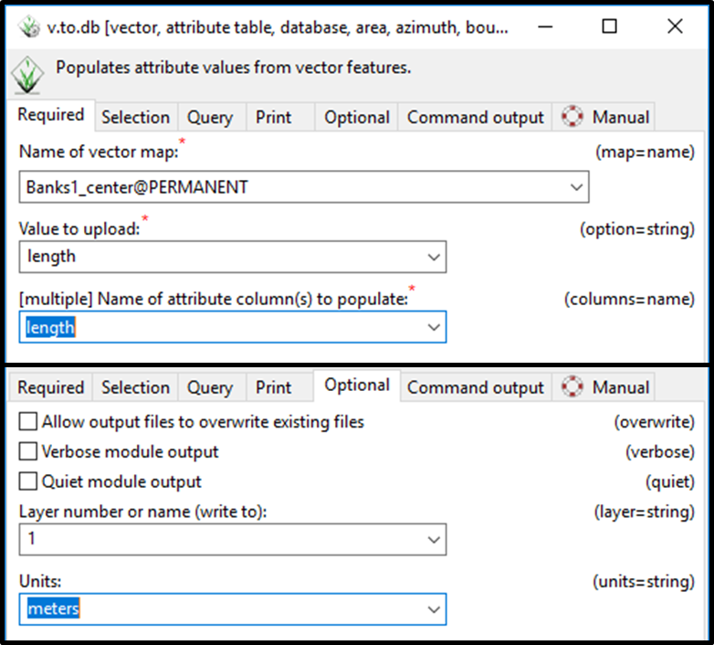

Figure 9. Windows for the *v.to.db* tool and settings to input in the *Required* and *Optional* tabs.

In this handout, we talked about how to digitize lines and the methods for digitizing them in GRASS GIS. We also learned how to install add-on packages and use the v.centerline tool to collapse lines to a single average line. These skills will proof useful on the next handout, where we learn how to use those centerlines to extract and graph raster cells that intersect our lines, to calculate slope values to input into our classification scheme!

Micheli, E. R., J. W. Kirchner, and E. W. Larsen. "Quantifying the effect of riparian forest versus agricultural vegetation on river meander migration rates, Central Sacramento River, California, USA." *River research and applications* 20, no. 5 (2004): 537-548.

Rosgen, D.L., 1994, A classification of natural rivers: CATENA, v. 22, p. 169–199, doi:10.1016/0341-8162(94)90001-9.

**Appendix**

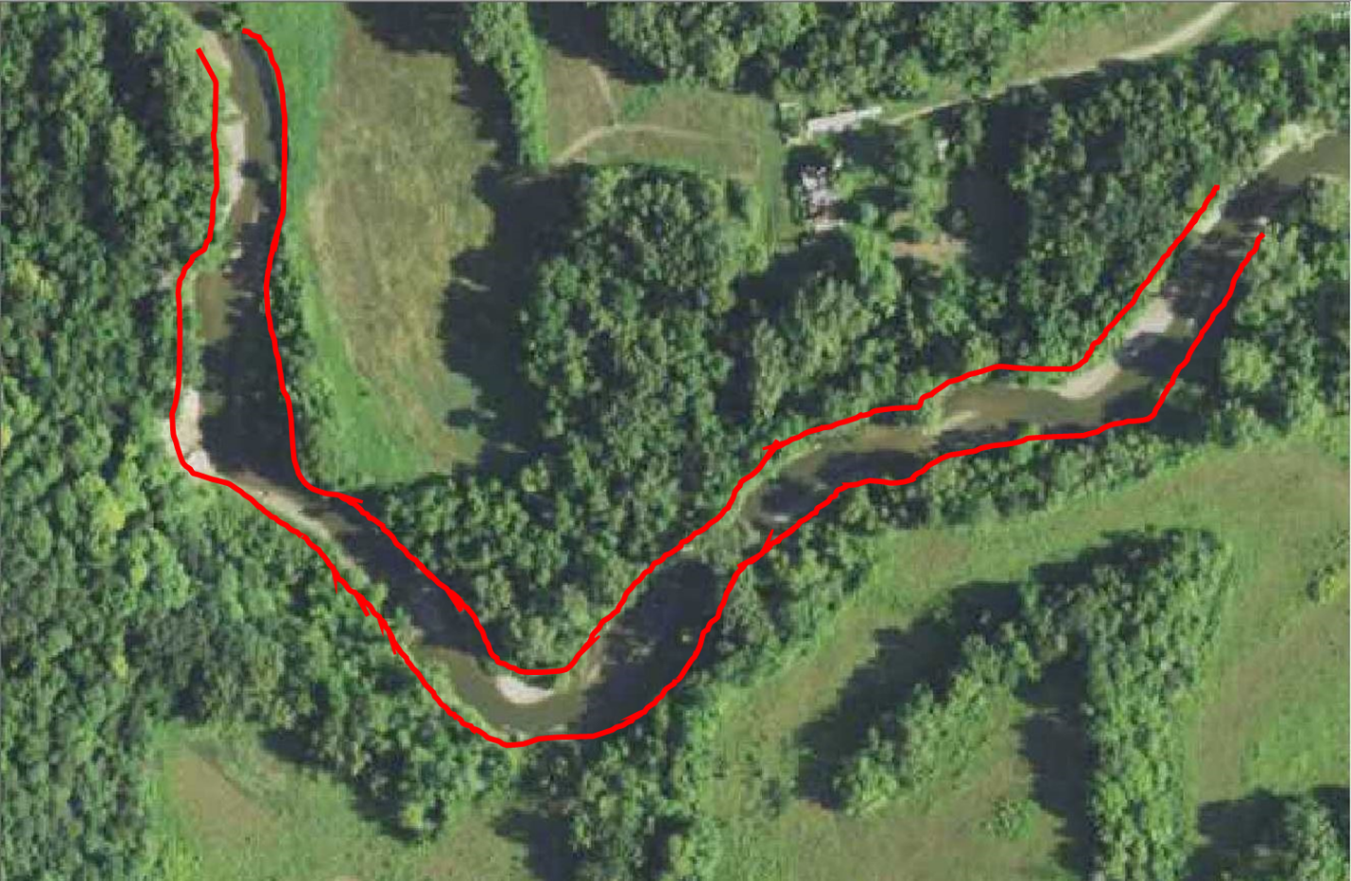

This method of bankline digitization utilizes the crown (middle) of the trees that surround the river to identify a reasonable bankline. While it is possible that this method overestimates the width, it is likely that the surrounding trees are overhanging the river, so the crown is likely near the bankline.

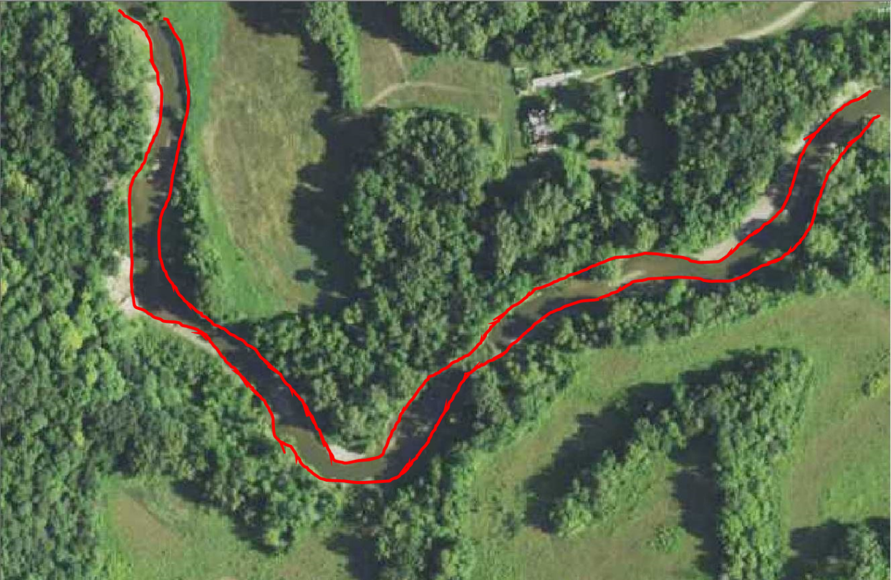

This method digitizes utilizes point bars, depositional features on the inside of a river meander bend, to approximate the banklines. In low flow situations, this is reasonable, but may increase sinuosity by

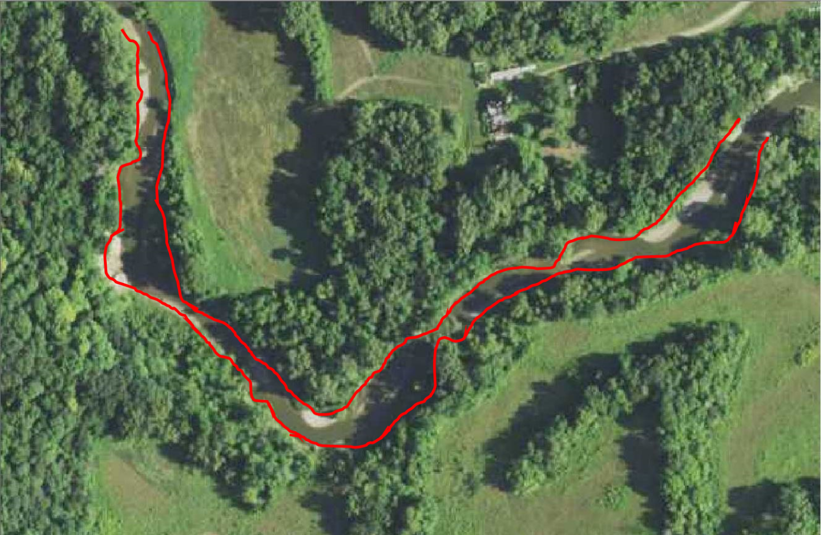

This method digitizes the boundary of the treeline, as we do not technically know where the bank exists underneath the tree and this focuses more on the water we can see. Notice how “lumpy” the boundary lines look here. You can imagine this may add unnecessary distance to the end product.

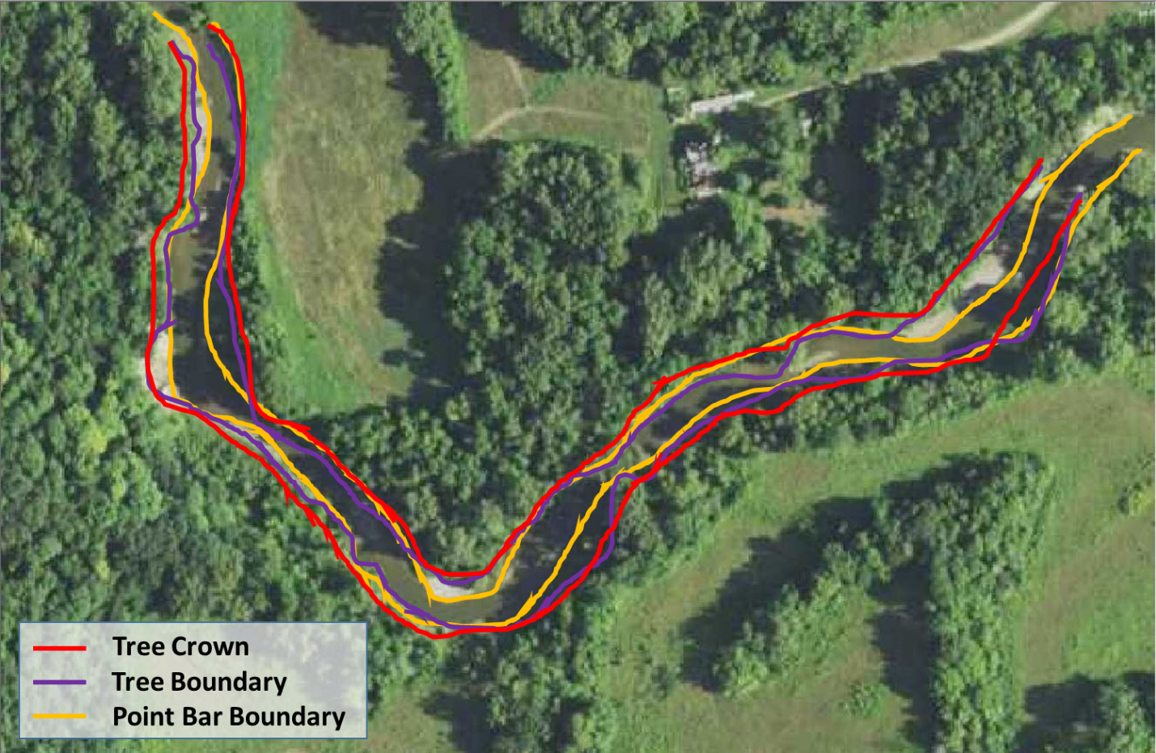

Here are all three methods are shown on top of one another. The preferred and suggested method is to use the crown of the tree when the bank is not obviously visible. This provides the most reasonable approximation of the bankline, when not visible.